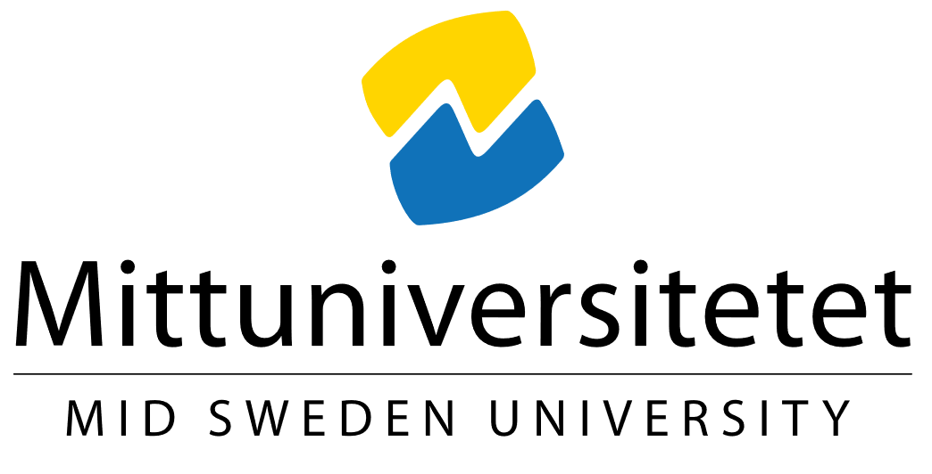
Polar Law Symposium 2024 September 23-25 Östersund, Sweden

Please provide us with following information:

Title of the presentation or seminar:
What type of presentation? Lecture, short lecture or seminar.
To which of the two conference themes does your abstract belong?
- Theme 1: Implementation of international minority- and indigenous law at national levels
- Theme 2: Governance, resources, security, and jurisdictional issues in the circumpolar area
Presenter’s name:
Professional title:
University:
Country:
Abstract (maximum 250 words):

